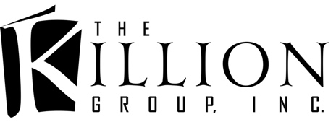
Publishing • Editing • Formatting • Blurb Writing • Cover Design • Branding
*NEW! Foil Stamped Printing • Web design • Logos & Swag…and much more…
____________________________________________________________________________________________________________________

Thanks for getting in touch! We are very interested in working with you on your project.

LET’S GET STARTED on your UPLOAD

Please fill out the questionnaire below and send it to Jennifer@TheKillionGroupInc.com

OTHER SERVICES:

- • eCover: $150  - • Spine and back addition: $75  - • Formatting: e-Books: $40-$60  - • Formatting: Print Books: $80  - • Uploading books to E-Retailers: $30 per title  - See all our services! | - • Line Edits: .007¢ / per word  - • Developmental Edits: Starting at .008¢ / per word  - • Beta Reading or Proofread: .006¢ / per word  - • Blurb Writing: $40+

Uploading Questionnaire
Thanks for getting in touch! We are very interested in working with you.
Please fill out the questionnaire below and send it to Jennifer@TheKillionGroupInc.com.
If you have any questions feel free to ask.

We charge $30 for uploading to Kindle/KDP, B&N (Nook) Press, and D2D (Draft2Digital) who distributes to iBooks, Kobo and some smaller sites.

We can upload directly to Kobo if you wish.

We DO NOT upload to Smashwords.

***
READ THIS:
We will not be able to upload until you turn OFF your security login on your KDP account. If you have your account set up to notify you / block login until you approve, when someone logs in, go turn that off before uploading begins. No exceptions.
Are you doing a PreOrder?
If PreOrder, what date do you want to start the PreOrder?
What is your ACTUAL release date?
What is your login / password to each site?
What is your cell phone #? I HAVE to be able to call you if there’s a problem and we’re on deadline.
What is the title ?
Subtitle?
Series name ?*
*KDP now has a new field to fill out about Series. So I need not just the Series name, I need to know what number in series this book is, and I also need a 1 or 2 sentence blurb/ description of the SERIES.
Author Name ?
What is the ISBN if you have bought one from Bowker? You need 1 for ebook and 1 for Print if you bought them. OR you can use the free ones offered by the eStores.
ISBN ______________________
- Name of author or publishing company you listed as “owning” the ISBN you bought. _______________________________________________
I want to Use FREE ones. _________
Do you want matte or glossy cover finish (if doing) on your Print book?
Cream or White interior paper ?
What is your Back Cover Copy / Blurb ?

What 5-7 keywords do you want to use? (These are words search engines use to find your book)

What Category / Genre do you want your book listed as?

What price do you want to list the eBook? (Print books, Amazon sets a min price and we’ll have to go from that point )

